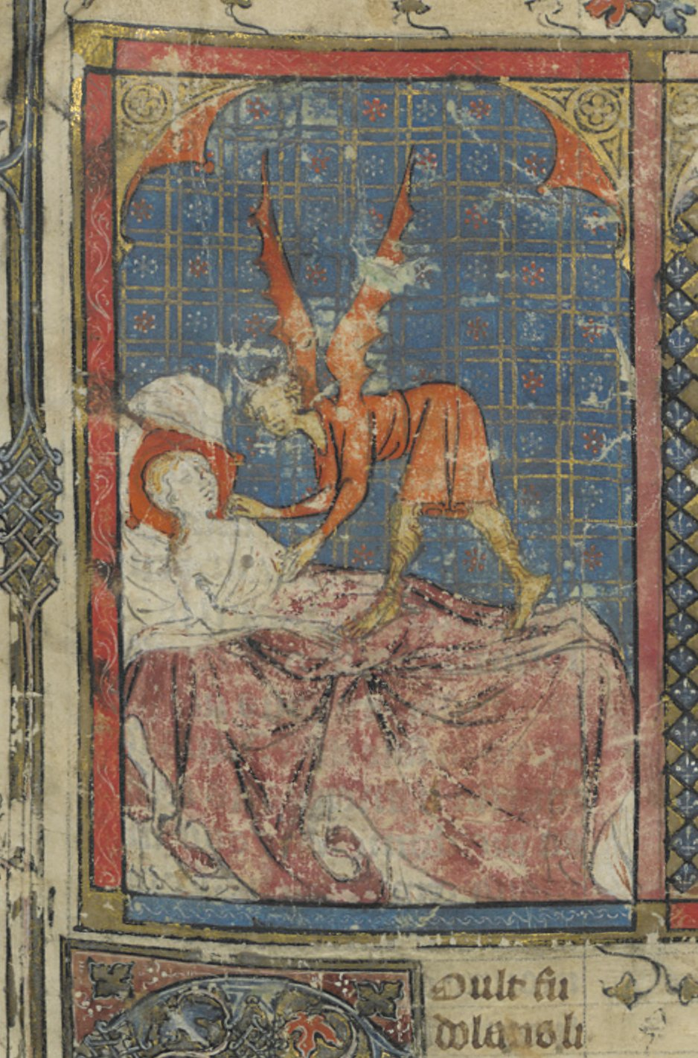**9th Postgraduate Conference Medievalism Transformed**

**Magic in the Web of It**

**Sorcery and the Supernatural in the Middle Ages**

**14th June, 9:30am – 5pm, Lecture Room 3, 1st floor of Main Arts Building**

**Keynote:**

**Dr Catherine Rider (Exeter University)**

**‘Treating Magical Illnesses in the Middle Ages’**

**Registration fee: £15 (including lunch and refreshments)**

**Cheques to be made payable to Bangor University**

**and sent by 6th June to:**

**Medievalism Transformed Conference**

**School of English**

**Bangor University**

**College Road**

**Bangor**

**LL57 2DG**